82nd Annual MATA Spring Exhibition
Call for Entries p.1 / Guidelines pp.2-4 / Entry Form pp.5-6

What: 82nd Annual Milwaukee Area Teachers of Art (MATA) Spring Exhibition - 2024
Milwaukee’s oldest juried exhibition featuring the art of artist/art educators.
(Cash prizes totaling more than $1000 were awarded in 2023!)

Who: Current and retired art teachers may enter up to three original works in any media.
- All entries must have final dimensions, including frames, included on the entry form.
- Entries should be rank ordered by the artist. After all entry forms are received the needed space will be evaluated. If there is not enough room for all entries, all of the 3rd ranked pieces will be cut.
- Notification about the status of 3rd ranked entries will be given by April 19th.
- No images are needed with the entry form.

Only current, original works of art are eligible for inclusion in the exhibition.
Reproductions of original works will not be accepted.

When: Entry Form Deadline: April 12, 2024
The exhibition runs from April 27 – May 31
Delivery: Drop off work Saturday, April 27 between 9:00-10:30 am
Opening Reception: Sunday, May 5 2:00 – 3:00 pm
Take Down: Pick up work on Saturday, June 1 between 9:00-10:30 am

Where: Milwaukee Public Library - Central
814 W. Wisconsin Ave., Milwaukee
Entrances on Wisconsin Ave., N 8th St. and Wells St.
Free short-term parking on Wisconsin Ave.
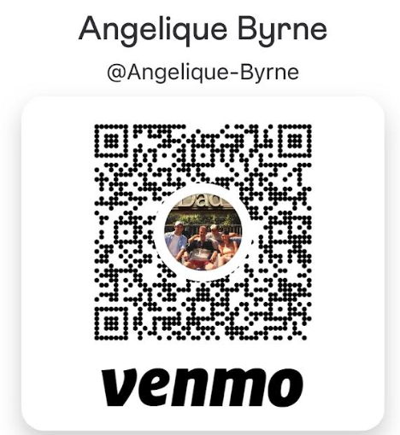
How: EMAIL or MAIL Entry/Waiver Form to:
Chris Lois christopherjlois@gmail.com
or 1400 Mockingbird Ct, Oconomowoc, WI 53066

$40 ENTRY FEE OPTIONS
1. Bring entry fee when delivering art on 4/27.
2. Include entry fee check made out to MATA with mailed form.
3. Send payment through Venmo to Angelique Byrne.
Label: “MATA Show Payment”

Please indicate payment option choice on entry form.

(Carefully follow the Submission Guidelines, pages 2-3 of this document.)

Entry Form Deadline: April 12, 2024
The official Entry/Waiver Form is pages 4-5 of this document. It may also be downloaded from the MATA website: www.MilwaukeeAreaTeachersofArt.com

82nd Annual MATA Spring Exhibition - 2024

SUBMISSION GUIDELINES:

Area Art Teachers may enter up to 3 pieces of their original art, produced within the last two years.

SUBMIT ENTRY FORM via EMAIL or MAIL:

TO: Chris Lois christopherjlois@gmail.com or 1400 Mockingbird Ct Oconomowoc WI 53066

SUBJECT: MATA ENTRY – “Artist’s Name”

MESSAGE: “Artist’s Name” MATA Spring Show 2024

PREPARATION FOR EXHIBITION:

WIRE HANGERS ONLY with the wire at least one inch down from the top of the work.
NO SAWTOOTH HANGERS – such work will be excluded!

ALL WORK must be FRAMED or otherwise appropriately
PREPARED FOR EXHIBITION and INSTALLATION.

Participants using any form of technology must provide and set up their own supporting equipment. This includes sculptures or 3D work requiring pedestals or other supports that are larger or beyond the scope of what MATA provides. If installation of the artwork is challenging and requires special directions, the artist should plan to be present to assist with the installation on Saturday, April 27th, or have made special arrangements.

CALENDAR
April 12 | Entry Forms Deadline
April 19 | Notified of status of 3rd-ranked entries
April 27 | Deliver work 9:00 – 10:30 MPL Central Library *Please be prompt!*
April 27 – May 31 | Exhibition Dates
Sunday, May 5 | Artists Reception and Awards Event 2:00 – 3:00 pm
June 1 | Pick up work 9:00-10:30 am

www.MilwaukeeAreaTeachersofArt
Entry Checklist (keep for reference) – Form Deadline: Apr 12, 2024
____ Entry/Waiver Form
____ Option A: Email entry form to christopherjlois@gmail.com
____ Option B: Mail to: Chris Lois 1400 Mockingbird Ct Oconomowoc WI 53066
____ $40 Entry Fee (Indicate your preference on the entry form.)
____ Option A: Bring payment at drop
____ Option B: Send check made out to MATA along with entry form
____ Option C: Venmo Angelique Byrne: Label MATA Show Payment

Notification of the status of 3rd-ranked entries will be given via email by April 19, 2024
Accepted work must be delivered and ready to hang/display April 27, 2024. (See Guidelines)
Milwaukee Public Library – Central 814 W. Wisconsin Ave., Milwaukee
Entrances on Wisconsin Ave., N 8th St. and Wells St.
Free short-term parking on Wisconsin Ave.

Dear Entrants,
MATA's mission is to promote the professional and artistic growth of area art teachers by, in part, providing opportunities to showcase their continued work as artists. To that end, we are excited that our shows are open to all Milwaukee Area Art Teacher and Retired Art Teachers. Please share this information with other art teachers who would welcome the opportunity to show their work. And be sure to promote your participation to colleagues, family and friends!
Thank You!
Angelique Byrne, president
P.S Late deliveries make hanging the show more complicated than it needs to be. If you are unable to deliver your work on the delivery date please email us.
MataArtEducators@gmail.com
www.MilwaukeeAreaTeachersofArt
82nd Annual Spring Exhibition - Milwaukee Area Teachers of Art
April 27 - May 31, 2024 Entry/Waiver Form Deadline: April 12, 2024

Name:
Email:
Address:
Best Phone #:
School and District:
Teaching Status:
- active
- retired

Artwork Ranked #1 Title:
Price:
Media:
Dimensions (H/W/D) :

Artwork Ranked #2 Title
Price:
Media:
Dimensions (H/W/D) :

Artwork Ranked #3 Title:
Price:
Media:
Dimensions (H/W/D) :

Entry Fee Options:

- I will defer payment of my $40 entry fee to April 27, 2024 when I deliver my art work.

- I am including payment of my $40 entry fee with my mailed entry form.

- I will pay my $40 entry fee via VENMO as described on page 1.

MATA Annual Spring Show – Waiver of Liability and Commitment to Payment
I am aware that neither the Milwaukee Area Teachers of Art (MATA), nor the Milwaukee Public Library insures my artwork from damage or theft while it is a part of this exhibition. I release both MATA and the Milwaukee Public Library from any such liability. I will also pay my $40.00 entry fee on or before 4/27/24.
Signature:
Printed Name:
Date:
_ _ _ _ _ _ _ _ _ _ _ _ _ _ _ _ _ _ _ _ _ _ _ _ _ _ _ _ _ _ _ _ _ _ _ _ _ _ _ _ _ _ _ _ _

