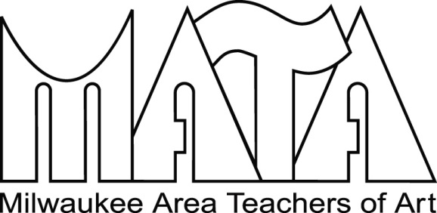
75th Annual Membership Show
April 10 – May 20, 2016

Milwaukee Public Library
W. Wisconsin Avenue, Milwaukee, WI

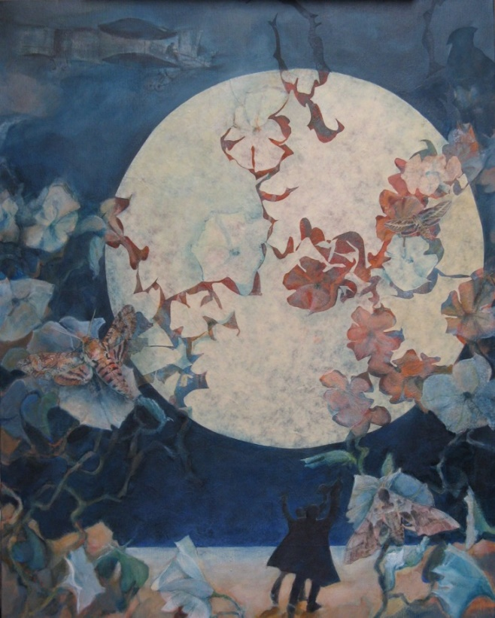

2015 Best of Show

“Navigating the Night” by Jean Sobon

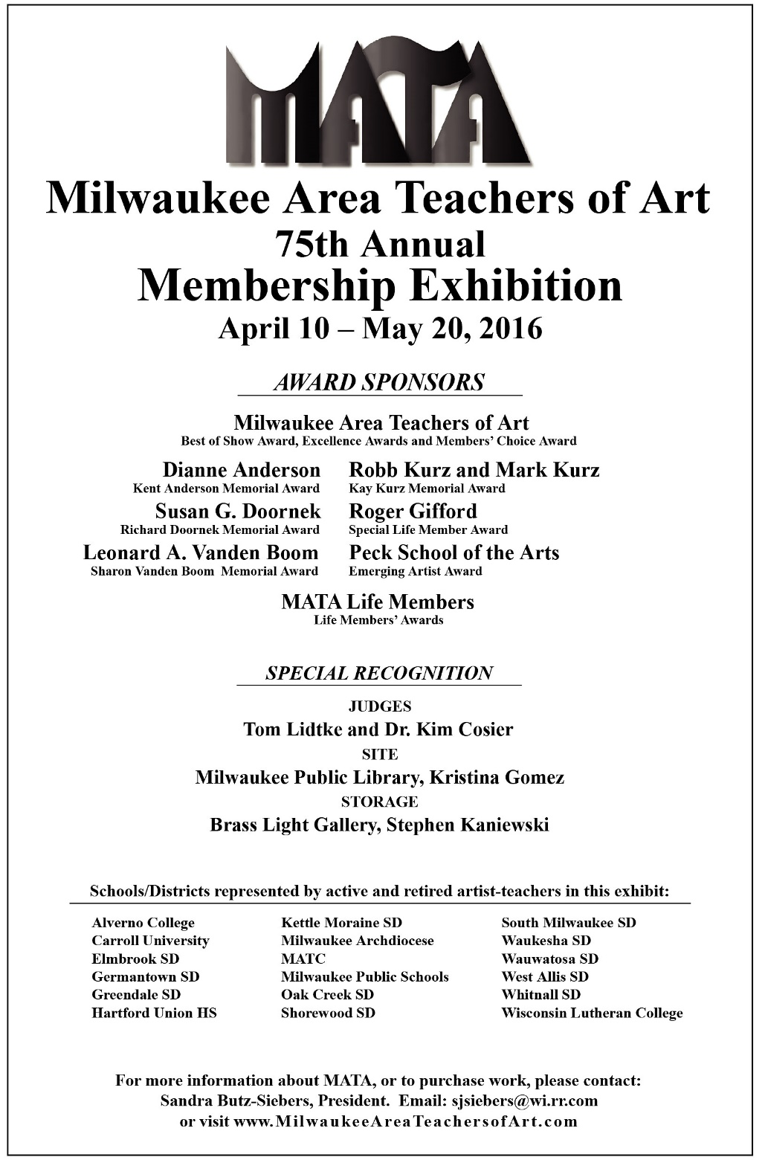
Dianne Anderson
Fragments
Handmade paper $400
The Key to Life
Handmade paper $400
Save the Trees
Handmade paper $400

Ann Baer
And Then There Were None
Acrylic on Canvas $500
Talking Heads
Recycled wood products $400
With Malice Toward None
Watercolor Crayon Collage $800

Kathy Barnes
Autumn
Mixed Media $300
Stars and Stripes
Mixed Media $300
Gentle Breeze with Spring Rain
Mixed Media $300

Kelly A. Belot
Vessel
Ceramic NFS
Wings
Glass $300
Jeanne Bril
Head Study
Air dry clay with acrylic paint $65
Self Portrait 1
Colored pencil, watercolor, papers $40
Self Portrait 2
Colored pencil, watercolor, papers $40

Jodi Brzezinski
Shell Study #3
Coffee and Ink NFS
Radiant
Ink, Colored Pencil NFS

Sandra Butz-Siebers
Lion’s Den Gorge
Acrylic on Panel $250
Witte’s Vegetable Farm
Acrylic on Panel $300
Momma Siebers’ Veggie Kindergarden
Mixed Media Book $45

Dave Cicero
Wood-fired Pot with Seashell Imprints
Stoneware $85
Stretched Ovoid with Dark Slip and Scalloped Rim
Stoneware $85
Stretched Form with Dark Slip and Cinched Waist
Stoneware $100
Amy Cropper
Geranium Hills
Collage $300
Geranium Underworld
Collage $300
Taking Hold
Ink and Collage on Paper $300

Peter Dahlke
The Hand of Miriam
Assemblage $999.99
Ever More
Assemblage $1000
Memento Mori
Assemblage $1500

Eddee Daniel
Saving the Tree
Photograph $650
Saving the Tree II
Photograph $650

Laura Dorow
Elevated View
Gouache $120

Virgi Driscoll
Rising Structures
Oil on canvas $2500
New Realities
Oil on canvas $2500

Heather Eiden
Shrine
Ceramic tile, beads, wood box $125
Cabinet of Curiosity
Clay, paper, glass, wood box $125

Gerry Geischer
The Searchers
Acrylic on Canvas $275

Paula Jacoby-Spehert
The Candidate
Ceramic $1 Billion*
*Real price: Our values as a nation
and our right to claim the moral High Ground

Robin Jebavy
Red
Oil on Canvas NFS
Steve Langenecker
Chinstrap Penguin
Watercolor $300
Operation Migration
Oil on Canvas $800
White Bantam
Oil on Masonite $500

Emily Liefke
Out of the Water, I am Nothing
Acrylics, Sharpies, Love $300

Jim Maki
Sanctuary, Inside, Out
Watercolor $300

Eugene Mecikalski
Some Hummingbirds
Color woodcut $350
Scarlet Macaws
Color woodcut $375

David A. Powell
“X” Marks the Spot
Wood and Found Objects $400
Seeing the Future 2 Too
Wood and Found Objects $1000

Jean Sobon
Altered Patterns
Mixed Media on Canvas $300
The Distance Between Us
Mixed media on Canvas $300

Sharon Strickler
Cans
Oil on Canvas BO
Cans
Mixed Media BO

Victoria Tasch
Vancouver/Victoria
Accordion fold book $200
Tokyo
Accordion fold book $200
MKE
Accordion fold book $200

James Toth
Anadromous
Carved Portland Cement $600

Jesse VanderBand
Tea Set
Ceramic $120
Octopus Vase
Ceramic $100
Ursa Major
Ceramic $100

Kathleen Walter
Change
Mixed Media/Assemblage $400
Raven’s Mythology
Mixed Media/Sculpture $800

Charles Wickler
Facing the Future
Acrylic on World Maps $1800
2 x TWO x 4
Acrylic on Paper $1500
Backing Art
Acrylic on Back of Artwork $1500

2016 Judges Statement
“We recognize that the act of art making, while juggling the many demands placed on teachers is difficult- and important. Art teachers who maintain an active practice are an inspiration to their students as well as their colleagues. This exhibition is fairly small but its scope is diverse in both media and style. It is exciting to see emerging artists and we look forward to following your careers!

Congratulations to the artists and to MATA on this significant anniversary of 75 years of existence!”

Dr. Kim Cosier - U.W. Milwaukee
Thomas D. Lidtke - Director Emeritus MOWA

Milwaukee Area Teachers of Art (MATA)
MISSION STATEMENT
MATA’s mission is to promote the professional and artistic growth
of its membership through fostering a social fellowship based on mutual concerns and interests, providing significant exhibition opportunities, and sponsoring relevant, member-driven programming.

Founded in 1940, MATA is open to anyone interested in creating art, teaching art, and/or advocating for art in our schools.

For more information about MATA or to purchase any of the artwork on display, please contact MATA President, Sandra Butz-Siebers
at sjsiebers@wi.rr.com
or visit
www.MilwaukeeAreaTeachersofArt.com
75th Annual MATA Show Awards
Award winners selected by Thomas Lidtke and Dr. Kim Cosier

Best of Show ($500)
Red by Robin Jebavy

Kay Kurz Memorial Award ($300)
Seeing the Future 2 Too by David Powell
Dick Doornek Memorial Award ($300)
Memento Mori by Peter Dahlke
Sharon Vanden Boom Memorial Award ($250)
Altered Patterns by Jean Sobon
Kent Anderson Memorial Award ($200)
Stretched Ovoid by Dave Cicero
Roger Gifford Special Recognition Award ($200)
Anadromous by James Toth
Life Members’ Awards (2@$200ea)
Saving the Tree by Eddee Daniel
MKE by Tori Tasch
Pelican Award of Excellence ($100)
Some Hummingbirds by Eugene Mecikalski
Schwanke Award of Excellence ($100)
Momma Siebers’ Veggie Kindergarden by Sandy Butz-Siebers
Schroedter Award of Excellence ($100)
Stars and Stripes by Kathy Barnes
Boerner Award of Excellence ($100)
Talking Heads by Ann Baer
Peck School of the Arts Emerging Artist Award ($100)
Operation Migration by Steve Langenecker

Members’ Choice Award ($100)
to be determined at the April 16th reception

